

**SCHOOL OF ARTS AND SCIENCES  
DEPARTMENT OF COMPUTER, INFORMATION SCIENCES AND MATHEMATICS  
  
  
  
CUSTOMKYBRD**  
A Website Design Proposal

Presented to

the Faculty of the Department of Computer, Information Sciences and Mathematics

University of San Carlos

In Partial Fulfillment

of the Requirements for the CIS 1102 – Introduction to Computing  
  
  
  
**Prepared by:  
BARCENILLA, Jomer Allan G.  
Group 3 - Team 6**

**Submitted to:  
Ms. Blasminda Catubig Mayol**

December 2020

**Name of the website:**

**Customkybrd**

www.customkybrd.com

**Concept:**

This website is about advertising and selling keyboards, specifically custom-made keyboards that are ready made or to be assembled according to the preferences of the customer. This website contains forums designed to inform buyers and enthusiasts of the latest news, information, and recommendations about custom keyboards or the mechanical keyboard market.

**Purpose:**

The purpose of this website is to promote and sell customized mechanical keyboards. This is to encourage clients that having a great keyboard can be effective in increasing one’s productivity in work, school, or gaming. A keyboard is one of the most essential input devices in your desk and our purpose is to help you design or construct the perfect keyboard according to your liking. For optimal gaming experience and improved productivity, specific switches are made available to suit one’s choice. The intention of this site is to enlighten people of the importance of a keyboard with the help of forums. This is used to sell custom keyboards that results in feeling the full experience that no other keyboard can give.

**Target Audience:**

This website targets a niche market of keyboard enthusiasts and people who plan to venture into customized mechanical keyboards. Gamers are also part of this criteria as having a customized keyboard can greatly affect how they play the game because it can enhance their performance and ergonomics. Professional typists and programmers are also a target audience as they are the people who usually use keyboards the most since it is a must in their jobs.

**Page 1: HOME PAGE**

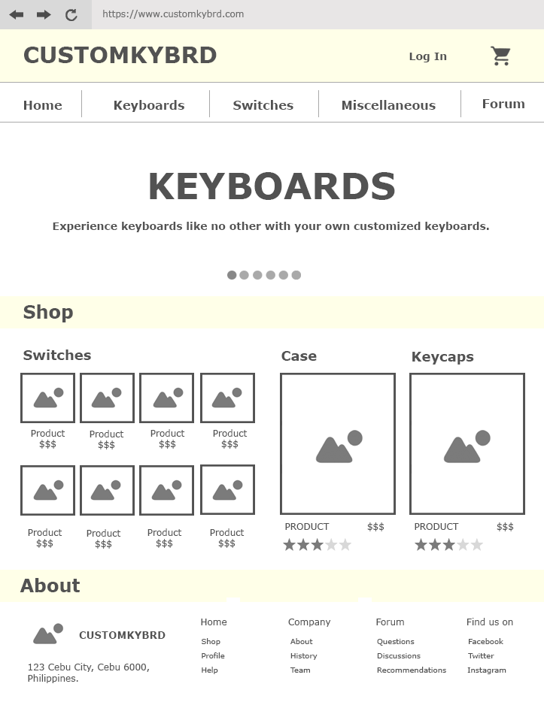

The home page is where you can navigate to the different sections or parts of the website. Once you open the site, the first to pop up is the home page where it showcases how the website works and what it is about. At the top, the login button and the cart button are placed at the right while the name of the website is placed on the left. Below the name of the website, there are buttons that navigate you to the different sections or parts of the site. The buttons are the home button, keyboard button, switch button, and the forum button. The home page shows the preview of the shop to allow the users to view it directly without any navigation. At the bottom of the home page, the information about the website is located. The “about” is where the general information about the website is located and it directs you to the history, about, and the team of the company. It also leads you to the different sections of the website such as the shop and forum. Lastly, the “about” part navigates you to the different social media accounts of the company on where you can contact and ask information.

**Page 2: SHOP - KEYBOARDS**

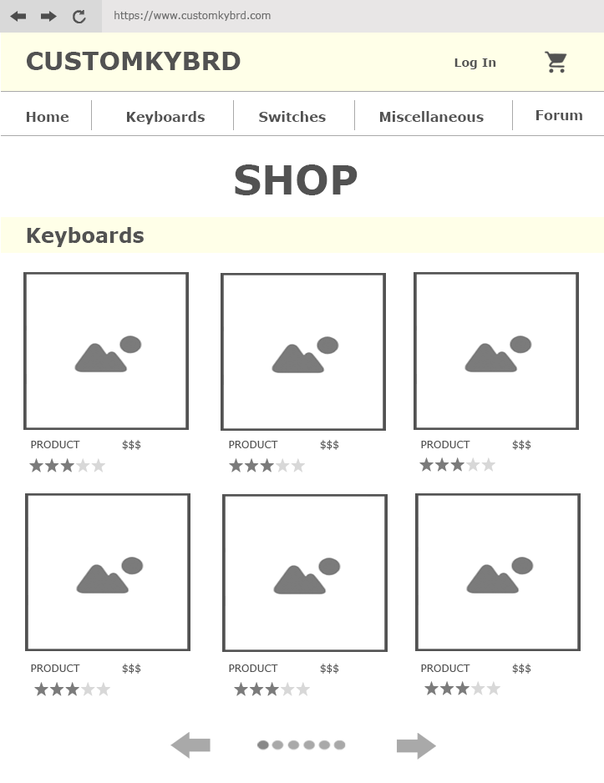

This is the page that shows shop that sells keyboards. This part shows the different kinds of keyboards which are pre-built and bare keyboards that lack switches. It shows the various products that are available, and it displays the name of the product, price, and its ratings from the buyers. It has buttons for the users to move to the next page of the shop to look for more options. Once the user presses the product, it directs them to the description of the product or the product page.

**Page 3: SHOP - SWITCHES**

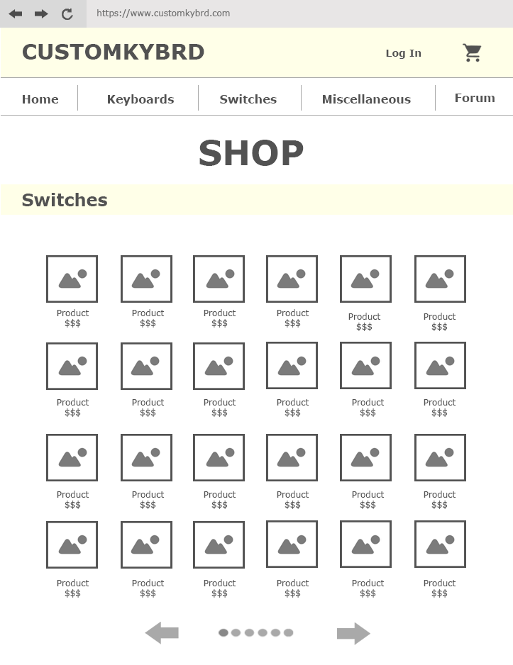

This is the page that shows the shop of the different keyboard switches. There are many options of switches such as mechanical switches and optical switches. The shop showcases the different switches that can be used to their keyboard build. This page has buttons that direct to the next page of the shop to look for more options for the different types of switches. Once the user presses the product, it directs them to the product page which reveals the description of the website.

**Page 4: SHOP - MISCELLANEOUS**

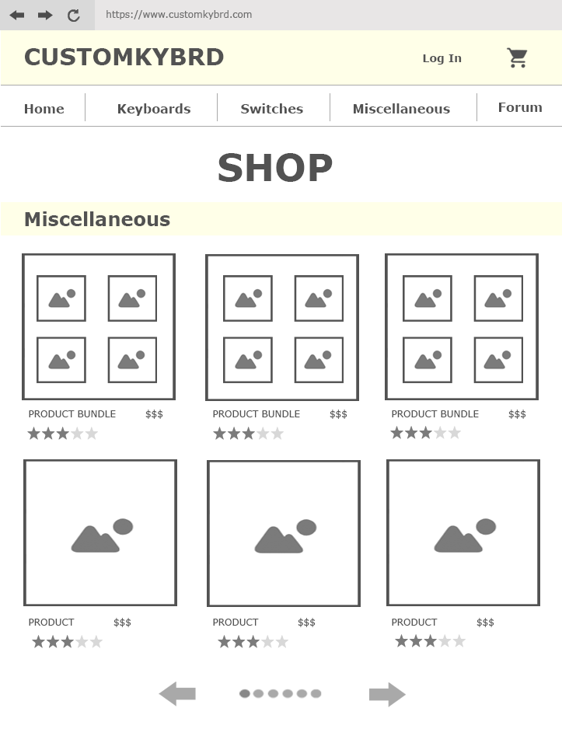

The miscellaneous part of the shop showcases the products that the buyers need in maintaining keyboards such as springs and lubricants. It presents the keycaps that can be interchanged with the current keycaps used in their keyboards. It shows the reviews and the price of the product as well as its image for the users to preview. Once the user presses the product, it directs them to the product page where the description of the website appears.

**Page 5: PRODUCT PAGE**

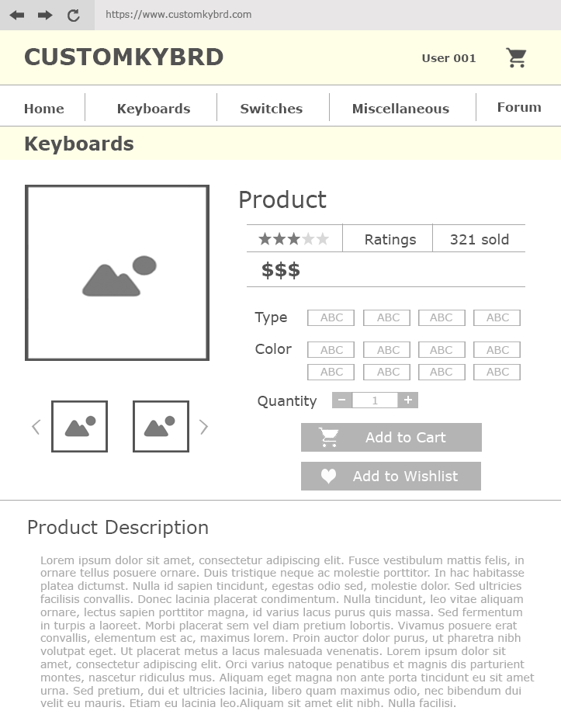

The product page shows the description and further information about the product selected. It indicates the images of the product in different perspectives which the users can view. It exhibits the name of the product, the number of reviews, average star rating given to the product and the amount sold. This page shows the pricing of the product and it allows the users to pick different colors and the type of the product they want. The quantity permits the users to input the amount of the product they want to buy. It also contains buttons for the users to add the product to their cart or to just add the product to their wish list.

**Page 6: FORUM**

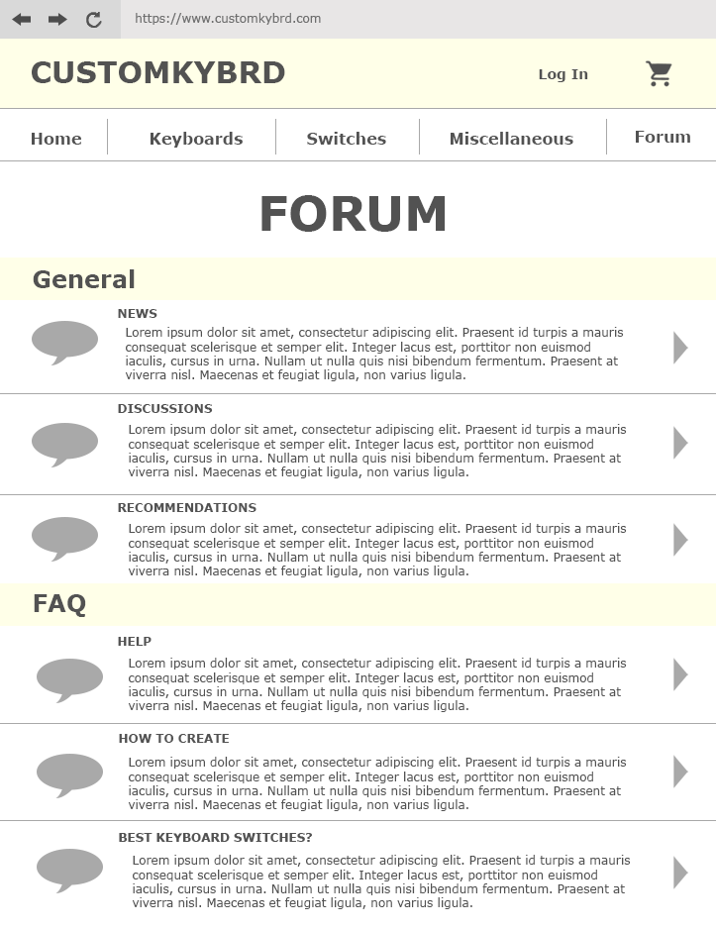

The forum shows the community section of the website where each user can ask questions, give recommendations and more. The general section shows the latest news of the keyboard market, discussion of the users on any topic about the computer hardware of keyboards and the recommendations of the different expert keyboard builders on what is the best keyboard that suits you. The FAQ or the frequently asked questions shows the queries that are more likely to be asked in the forum. Once the parts are clicked, it directs you to the page where it displays the different comments, suggestions, and answers of the members of the forum. As a user, you can also provide recommendations and ask questions to your fellow user.

**Page 7: CART**

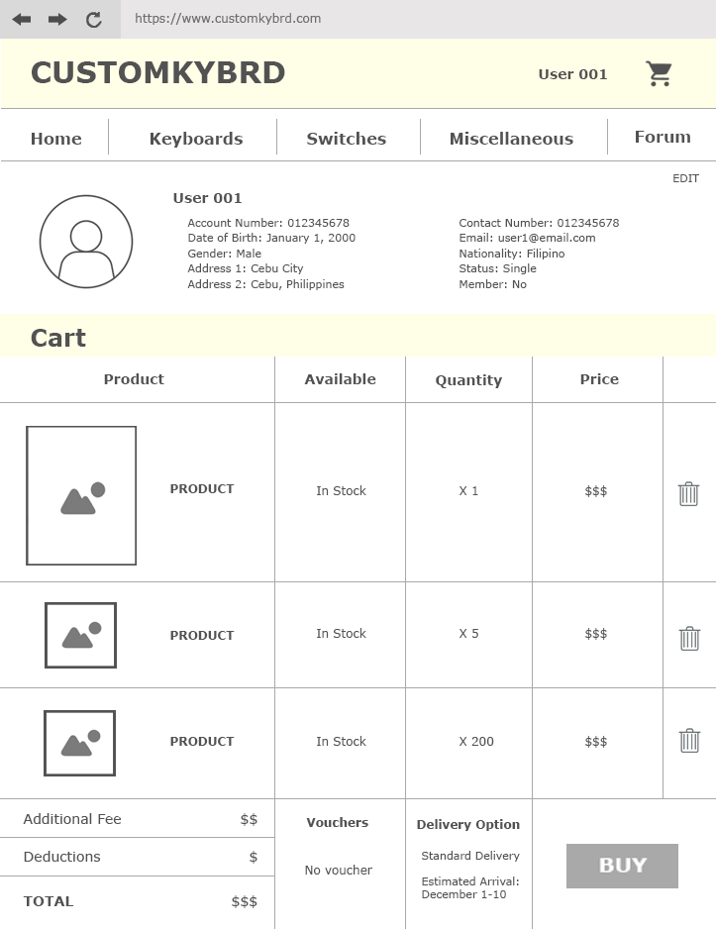

The Cart presents the variety of products that are placed in the cart from the shop. It exhibits the basic information of the users or the preview of the profile. On the preview of the profile, there is an edit button where the profile of the users can be changed. The cart shows the image and the name of the product, availability of the stock, the quantity that the user wants, price of the product, and the option to remove the product from the cart. It then indicates the additional fee, the deductions from discount or vouchers and the total price of the cart. It also shows if there are vouchers used and the delivery option of the buyer. Lastly, the buy button directs you to the payment options and inquires for the card information for the payment of the products.

**Page 8: LOG IN**

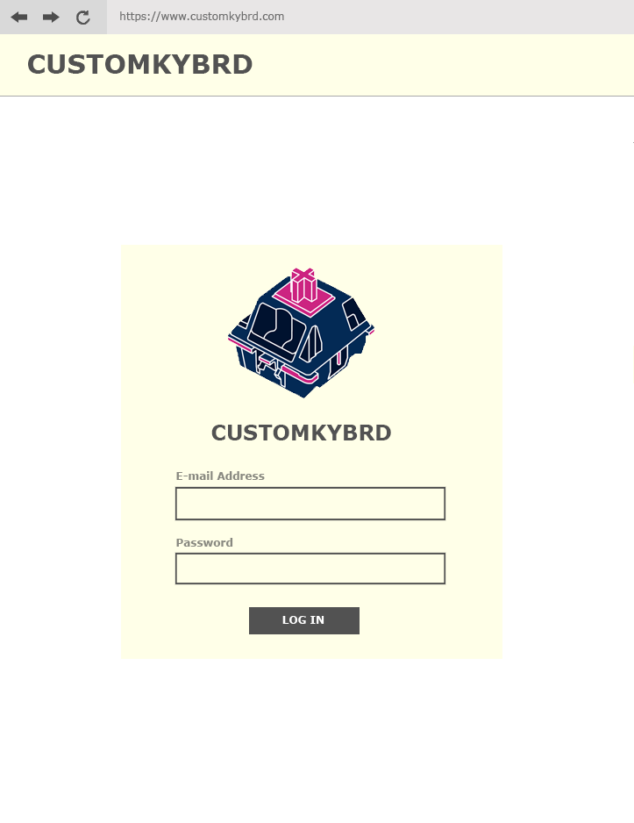

The Log in page appears when the users press the “Log in” button on the upper right of the home page. This is where the users input their account information such as their e-mail address and password that is linked to their account on the website. Once the log in button is clicked, the log in page directs the user back to the home page of the website, and the users can access the cart, the purchase buttons, and the comments in the forum.

**Page 9: REGISTER**

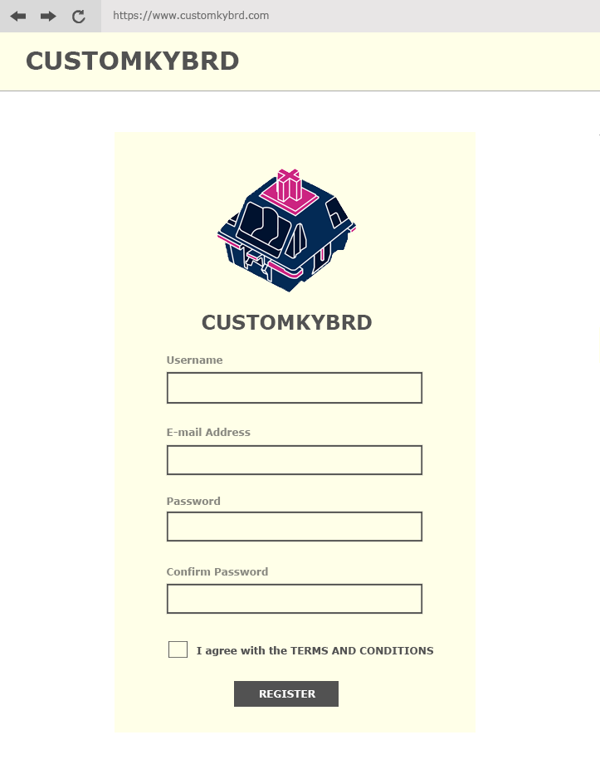

The register is where new users create an account, and it asks for the customer’s information. It requests for a username which will be displayed as the name of the account. The e-mail address is used to link it with the account and to give news or updates of the website. When creating an account, a password is needed and to ensure that the users correctly typed their password, there is follow-up for a password confirmation. A check box is visible to verify that the users agree to the ‘Terms and Conditions’ of the website. Lastly, the register button registers the account made and it can now be used.

